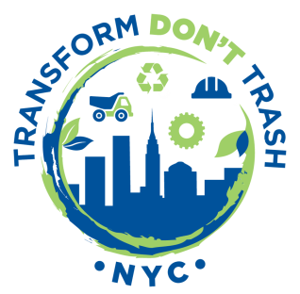
Small businesses deserve fair treatment from commercial trash haulers

New York City’s commercial waste system is broken. New York City’s restaurants, offices, and businesses generate a staggering 5.5 million tons of commercial solid waste each year. The system in place to handle all of that waste is fraught with problems of excessive pollution, inefficiency, low recycling rates, and unfair pricing structures.
The current system is bad for businesses. Waste haulers often don’t publish their prices, making it difficult for business owners to comparison shop and negotiate a fair collection rate. Haulers usually charge a flat monthly rate regardless of how much waste a business throws out. And while businesses should be rewarded for recycling (e.g. through lower collection rates), they often don’t even have the option to do it.

Commercial waste and YOU:
- What does your commercial waste invoice look like? Do you get charged less when you throw away less?

- Do you know what similar businesses pay to their carter?

- Does your carter provide recycling and/or composting services? Do you get a discount for recycling?

- Do you believe that small businesses should pay fair & transparent rates and be rewarded for sustainable practices?

TDTNYC is fighting for a commercial waste system that treats all businesses fairly and rewards them for doing the right thing. We’d love to hear about your experiences and talk to you about our efforts.

Please contact us at:
contact@transformdonttrashnyc.org

